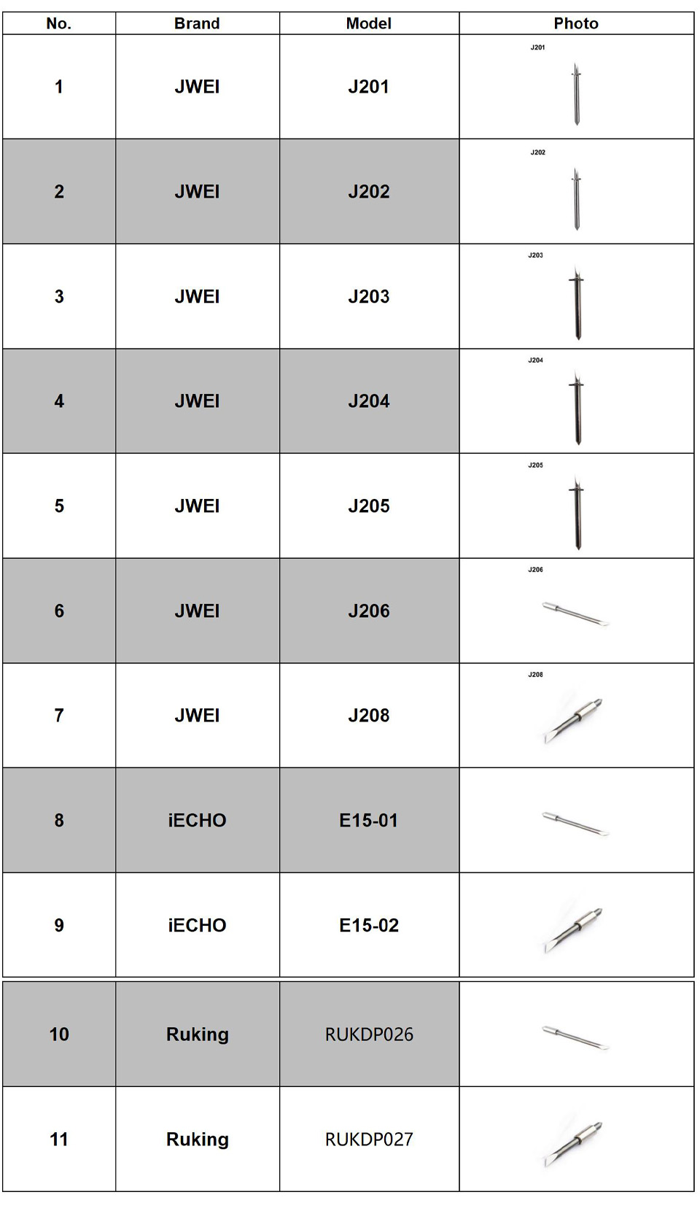
Shenzhen Oyea Machinery Co., Ltd.
Email: info@china-oyea.com
1659590865@qq.com
Web: www.china-oyea.com https://www.oyea-blades.com/

